ELECTRONIC PRESS KIT

About Girl A Girl B

What happens when two very good things finally come together? Musical magic! Twin sisters, Elizabeth Eccleston (Girl A) and Anita Eccleston (Girl B) have established contrasting careers in music over the past decade. Liz is a seasoned classical orchestral and chamber musician in Toronto; Anita is a successful jazz bandleader, arranger and song writer in Vancouver. Together with savvy BC cellist Doug Gorkoff (Black Dog String Quartet), this formula results in a trio that is constantly exploring new sounds, revisiting favourite songs through unique covers, and connecting with audiences through flare and fun. Twin harmonies enrich favourite cover renditions, while instrumental electronics inform an evolving sound steeped in both nostalgia and the unknown.

Artists

Elizabeth Eccleston: oboe, English horn, piano, vocals, ukulele, guitar
Anita Eccleston: trumpet, flugelhorn, ukulele, guitar, vocals
Doug Gorkoff: cello

Just the Facts

- A trio of Canadian artists committed to sharing music with their community
- Trained in jazz and classical, presenting rep ranging in styles from pop to folk, indie to electronic

Mission Statement

Since its inception, Girl A Girl B has been devoted to connecting with audiences and sharing new and uplifting musical experiences. We seek to:

- Share much-loved repertoire with our audiences
- Create and perform new music and new arrangements
- Enrich our community through engaging musical performances in casual, approachable venues from bars to house concerts
- Contribute to the high level of musical offerings nationally and globally by producing recordings and by connecting with online audiences

Selected Favourite Repertoire

- New Skies (Dan Mangan)
- High and Dry (Radiohead)
- Over My Mountain (Dougie MacLean)
- Claim On You (Anita Eccleston)

Reviews

“Fabulous singers and musicians. Nice harmonies. Wonderful varied repertoire, great originals and covers. Some of my favourites: Mad World, Dance Me to the End of Love, High and Dry, Ice Cream etc..." – July 22, 2019 (Suki Saggu)

“It was such an awesome treat to have Anita and Liz come out to The Dunes for a special night of music to celebrate their parents 50th Anniversary. The performance was very refreshing and included a line up of memorable covers. They shared along with some interaction with the audience a few original pieces that brought a great ambience to the room. I’m looking forward to following these two in their journey. Thank you again and hope we can have you back in the near future.” – September 2019 (Leah R. Segouin)

Photo

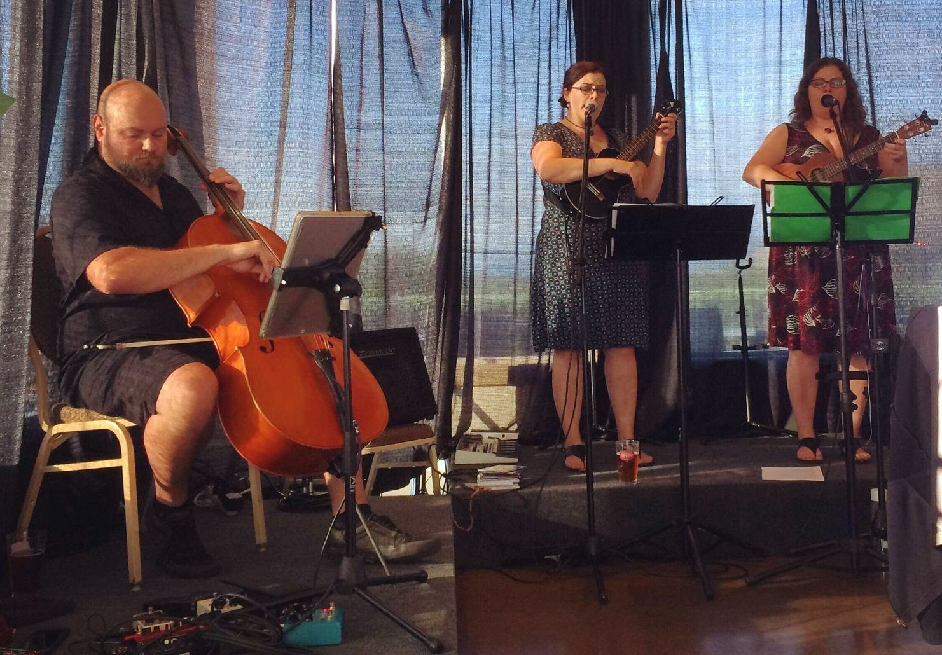

Contact Info

girlagirlb.com
girlagirlb@gmail.com

