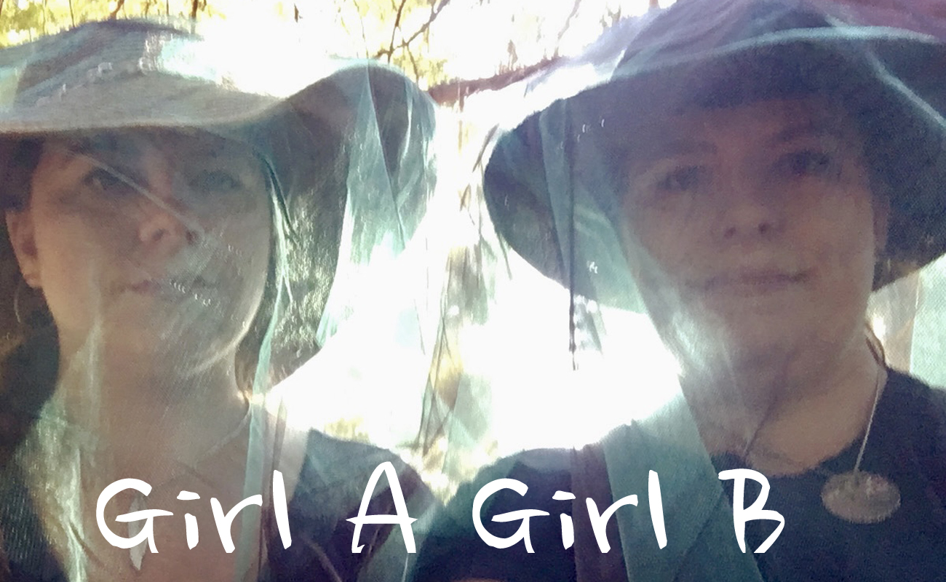

ELECTRONIC PRESS KIT

About Girl A Girl B

Twins Elizabeth and Anita Eccleston band together with cellist Doug Gorkoff in this nostalgia folk pop trio presenting sublime covers and original songs in vocal harmony with their electrified ukuleles and magic cello. Using oboe, English horn, trumpet, and flugelhorn, they draw on their jazz/classical roots to rock an eclectic compilation of tunes you forgot you knew that’ll suckerpunch you back in time. Girl A Girl B shows are a retro mixtape bathed in electronic experimentation.

Artists

Elizabeth Eccleston: vocals, electric ukulele, oboe, English horn
Anita Eccleston: vocals, electric ukulele, trumpet, flugelhorn
Doug Gorkoff: cello, effects pedals

Selected Favourite Repertoire

- Skye Boat Song (Scotch Folk Song)
- High and Dry (Radiohead)
- That Day (Poe)
- Fade Into You (Mazzy Star)
- Annie’s Song (John Denver)
- Fiddle and the Drum (Joni Mitchell)
- Always On My Mind (Willie Nelson)
- Lay Low (Dan Mangan)

Upcoming Performances:

Sat. May 13 @ 12:15PM Burnaby Blooms: Deer Lake Park, Burnaby, BC
Sat. July 1 @ 7:00PM Canada Day Street Fest Central Blvd - Central Blvd & Willingdon, Burnaby, BC
Reviews

“Fabulous singers and musicians. Nice harmonies. Wonderful varied repertoire, great originals and covers. Some of my favourites: Mad World, Dance Me to the End of Love, High and Dry, Ice Cream etc..." – July 22, 2019 (Suki Saggu)

“It was such an awesome treat to have Anita and Liz come out to The Dunes for a special night of music…The performance was very refreshing and included a line up of memorable covers. They shared along with some interaction with the audience a few original pieces that brought a great ambience to the room.” – September 2019 (Leah R. Segouin)

Photo

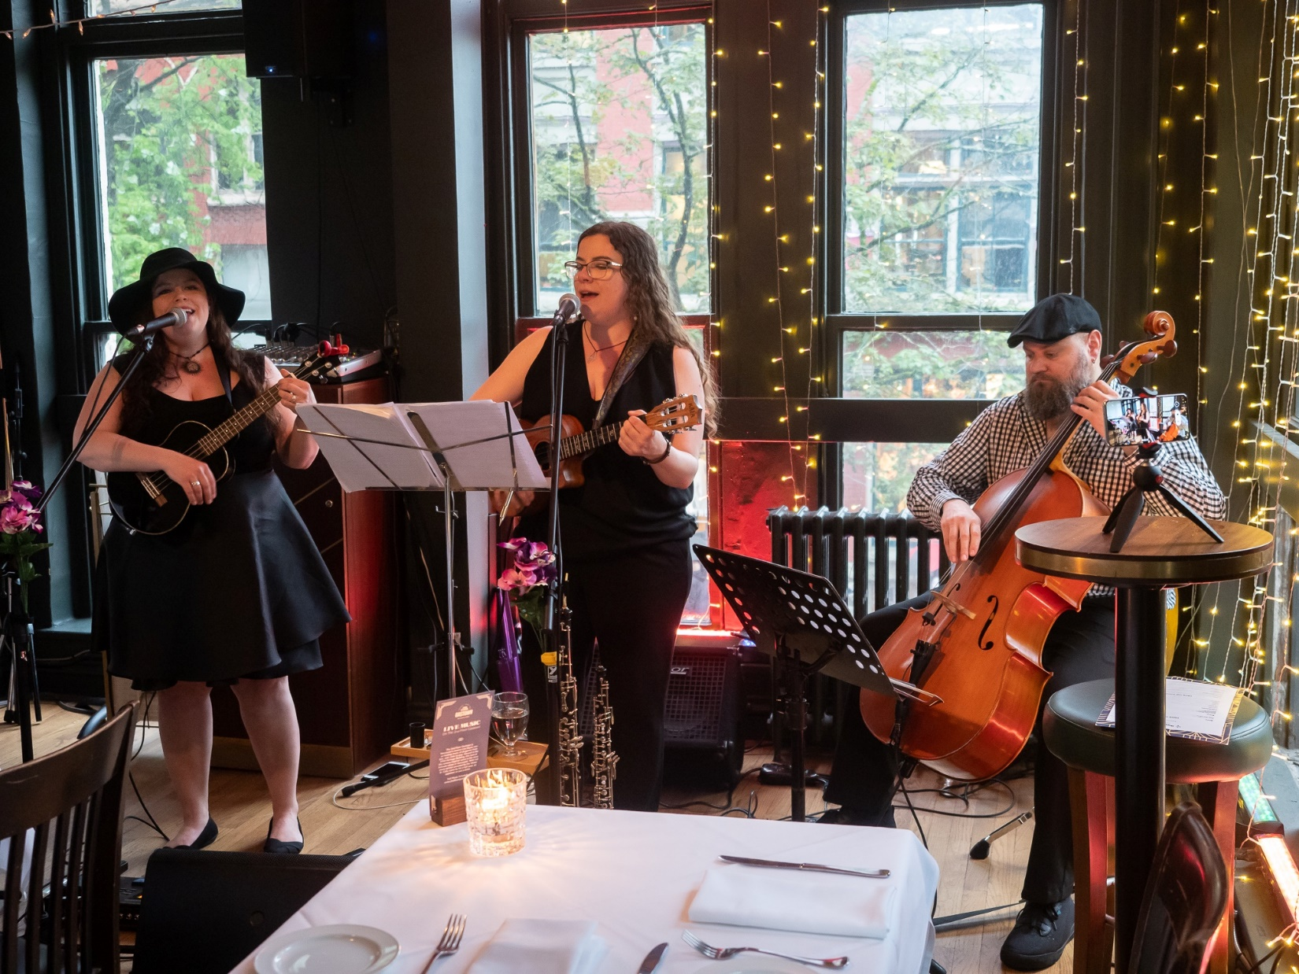

Contact Info:

Website: girlagirlb.com
Email: girlagirlbmusic@gmail.com
Facebook: facebook.com/GirlAGirlBMusic
Instagram: @girlagirlbmusic
Twitter: twitter.com/GirlAGirlB
Youtube: youtube.com/@GirlAGirlB

